Take-Home Exam
Use Matlab Solving Engineering Problems

By Dr. Clara Fang

Your ES 115 take-home exam consists of two independent problems. You will apply necessary Matlab skills that you have learnt to complete each problem.

Deliverables:

- Your project report should include the following:

  - A cover page showing your name, course, date, etc.;

  - The Matlab code for each problem;

  - The output or answer on Command window for each problem;

  - One-page summary to explain the approaches you undertook in building your Matlab code, any alternate approaches that you may have used, and any challenges that you have encountered and how you conquered it.

- Save you report “Yourfirstname_lastname.doc”, such as “John_Smith.doc”, and submit it to Blackboard.

Important: Refer to the course syllabus about academic integrity and the homework/project policy. (Copy other group(s)’ work will result in a failing grade for all involved).

1. Car and Train Motion (35 pts)

As shown in the following Figure, a train and a car are approaching a road crossing. At t = 0 the train is 350 ft. south of the crossing traveling north at a constant speed of 54 mi/h. At the same time the car is 150 ft. west of the crossing traveling east at a speed of 28 mi/h and accelerating at 4 ft/s².

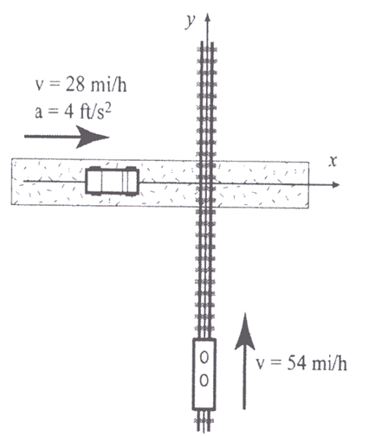

You are required to apply Matlab functions and skills, to complete the following tasks:

          - Create 11 x 5 matrix in which each row has the time (t) in the first column and the train position (y), car position (x), distance between the train and the car (s), and car speed (v_{car}) in the next four columns, respectively. The increment of t is 30 seconds. The distance is in the unit of feet. Speed is in the unit of mile/h.

          - In the above matrix, apply Matlab functions to determine the shortest distance between the train and the car, and when it occurs.

          - In the above matrix, apply Matlab functions to determine when the car will cross the intersection and where the train is at the time.

          - Plot how the train position, car position, distance between the train and the car, and car speed vary over the times, respectively. Each plot uses a separate x-y axis. If needed, please adjust the range of the times so that plots are displayed properly. All four plots are laid out in a grid/table format on the same figure.

Please adjust the appearance of your plots
  - Each line is in different color;
  - Each line is in different line type, e.g., Line 1 is dashed; Line 2 solid, Line 3 is dotted;
  - Each line is in different thickness;,
  - Add legends; a title; x and y axis labels;
Hint: Please apply “subplot” function in Matlab for plotting. You can find more information about “subplot” in the lecture notes (“plotting.ppt”) on blackboard, or Ch5.2 subplot in your textbook.

2. Data Analysis (15 pts)

Considering the following table of data representing temperature readings by each thermocouple sensor in a reactor,

Time (hr) | Thermocouple 1 (⁰F) | Thermocouple 2 (⁰F) | Thermocouple 3 (⁰F)
0 | 84.3 | 90.0 | 86.7
2 | 86.4 | 89.5 | 87.6
4 | 85.2 | 88.6 | 88.3
6 | 87.1 | 88.9 | 85.3
8 | 83.5 | 88.9 | 80.3
10 | 84.8 | 90.4 | 82.4
12 | 85.0 | 89.3 | 83.4
14 | 85.3 | 89.5 | 85.4
16 | 85.3 | 88.9 | 86.3
18 | 85.2 | 89.1 | 85.3
20 | 82.3 | 89.5 | 89.0
22 | 84.7 | 89.4 | 87.3
24 | 83.6 | 89.8 | 87.2

Apply Matlab to solve and answer the following questions:

- Create a matrix A corresponding to the above table. You can simply type the data, or use the file “thermocouple.dat”. You are not required to include the header of each column.
You can download “thermocouple.dat” from blackboard, under the folder “Matlab documents”.

- Find out maximum, minimum and average value of the temperatures measured by each thermocouple, and also determine when each value occurs.

- Determine the average temperature for each time, and include them as the 5th column of the matrix A.

